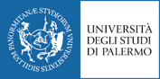
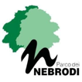
XV edition of “Scuola Italo-Russa di Formazione Avanzata in Scienze Ecologiche, Ambientali e Naturali”
Sustainable Development of The Italian and Russian Parks and Reserves

L’Istituto Italo-Russo di Formazione e Ricerche Ecologiche e il Parco dei Nebrodi: una esperienza di collaborazione e sviluppo del territorio

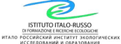

December 6, 2021
January 24, 2022
Microsoft Teams Platform activity
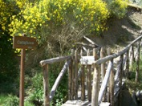
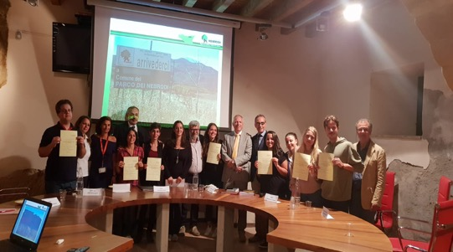

In-depth day between Italian-Russian Experiences with the Nebrodi Park experts
The Covid19 emergency has not allowed to carry out the classic Italian-Russian Summer / Winter schools in collaboration with the Nebrodi Park.
With the power of Knowledge and the help of Technology in the November-December 2021 period we will virtually go through the in-depth stages developed by the protagonists themselves who will NOT be able to replace the experience in the field with the hope that this can happen in the near future and that it will be useful as a stimulus to highlight the importance of experience in the field. We will try to reflect together on the transformations that the post-COVID19 era introduces in the Parks and in the development of the territory and international relations.

Winter School Programme 2021
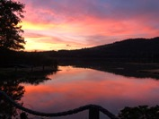

Day 1 – December 6, 02:30 pm

Welcome & Introduction

Prof. Massimo Midiri, Rector of UNIPA
Prof. Valerio Agnesi, Director of IIRFRE
Prof. Attilio Sulli, Director DiSTeM
Dott. Domenico Barbuzza, President of Nebrodi Park
Prof. Evgeny Martynenko, RUDN University, Moscow
Prof. Tatiana Shimko Lomonosov, State University, Moscow

IIRFRE presentation
Valerio Agnesi UNIPA
Physical and Geographical Framework of Sicily
Valerio Agnesi UNIPA

Activities for student: ideas for Nebrodi park videos
Andrea Savona, Leonardo Gatto, Daniela Parrinello, Matteo Cammarata UNIPA
Video 1

Day 2 – December 13, 02:30 pm
The How to educate to sustainability - The action of the Nebrodi’s Park
Sara la Rosa NEBRODI PARK

The Pleistocene site of San Teodoro Acquedolci /Human evolution
Luca Sineo UNIPA

Botanic Aspects of the Nebrodi Mountains
Angelo Troia UNIPA

Video 2

Day 3 - December 17, 02:30 pm
The impact of alien species on wildlife
Maria Giovanna Parisi - UNIPA

TITLE
Anna Popkova, RUDN Moscow

Double title UNIPA-RUDN: the student experiences
Giuliana Amorello

Video 3

Day 4 - January 12, 02:30 pm

Evaluation of landslide hazard: concept, methods and case studies
Christian Conoscenti - UNIPA

A process-based approach to erosion by water: examples of models and case studies
Aleksey Sheshukov - KANSAS STATE UNIVERSITY

Video 4

Day 5 – January 18, 02:30 pm

Sicilian Volcanism in Sicily
Silvio Rotolo - UNIPA

TITLE

Massimiliano Fenice UNITUS

TITLE

Rosario Miceli UNIPA
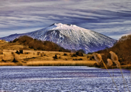
“The Nature, a precious asset for our health”

TITLE

Marcello Tropeano UNIBA

Day 5 – January 25
Cerimonia conclusiva
(S. Agata)
Conclusioni

